Peter Julius M. Estacio
Grouped with:
Niño Aloysius V. De Mesa
Christian James S. Madariaga
ENGG 151.01-A
April 26, 2026

Early Work for Project 3: Linear Time-Invariant System Simulator

As of April 26, 2026, major progress has been made on the project. LTI simulation is functioning as intended, making use of dynamically allocated fixed-size arrays for processing and handling signal data. The simulation function can process both individual data manually entered via the console, as well as reading signal files as per the project’s specifications. The function is also able to iterate on previous calculations using pointer arithmetic and dynamic array allocation. Additionally, a basic user interface has been implemented, allowing all user commands specified in the project specs. Basic user input validation has also been implemented, keeping the main user interface robust. Lastly, an output log file is created upon calculating simulation results. As of now, reading signal files from files and manually entering signal data are simulated independently, as their results currently do not affect each other. Thus, further work includes integrating both methods properly into the program for simulation, tweaking the function to allow single signal input samples as a parameter, and reviewing all program functions to precisely follow specifications. A screenshot of the current program output is shown below.

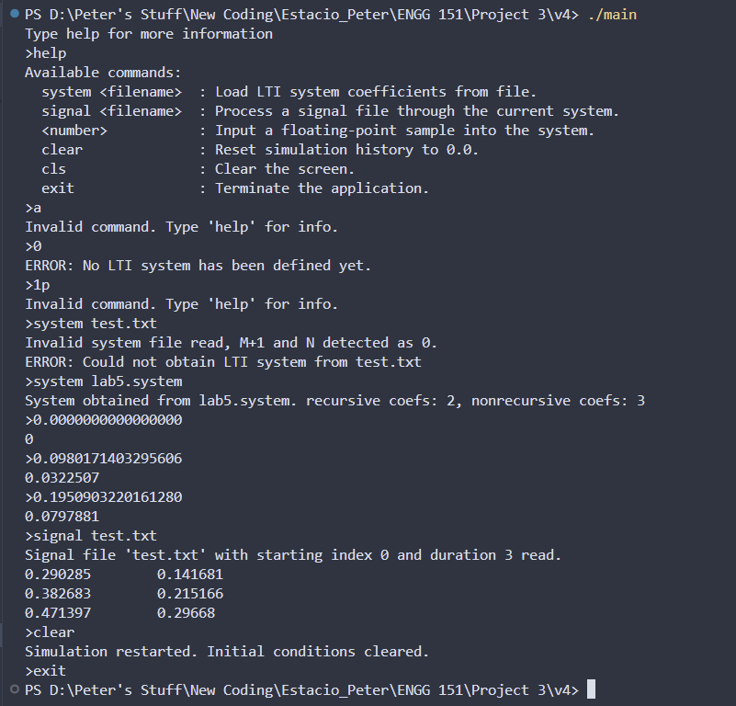
sample screenshot – executable main.exe run and resulting output to console

sample screenshot – compilation on Visual Studio Code

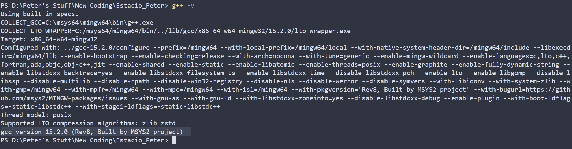
compiler version – gcc version 15.2.0 (Rev8, Built by MSYS2 project)

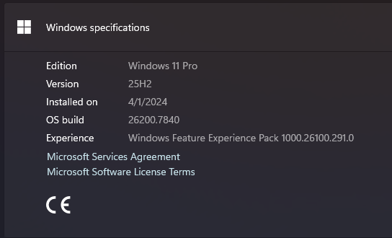
operating system - Windows 11 Pro, 25H2, build 26200.7840
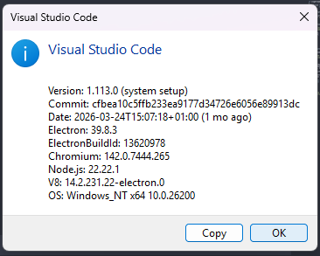
IDE – Visual Studio Code ver 1.113.0

Project Evaluation
Item | Points | Rubrics
early work | 8/8 | (all or nothing)  8: at most 10% of the code in the final implementation differs from that in early work submission
implementation and testing environment report | 4/4 | 4 - all instructions followed correctly
Basic Test | 50/50 | 0 - at least one computation in the basic test is not done correctly or C++ vectors or equivalent structures are used in simulating an LTI system  50 - correctly simulates the LTI system provided in the basic test for all inputs provided
 | 6/6 | 6 - screenshot submitted showing the correctly computed output as it appears on the console output
generality of simulation | 6/6 | 6 - LTI systems are simulated correctly and efficiently at all times
simulation function(s) | 6/6 | 6 - LTI systems are simulated correctly and efficiently at all times, by function(s) as specified
processing of signal files | 4/4 | 4 - The file is opened only once and the first line of the signal file is processed correctly and separately from code processing the rest of the signal file
processing of system files | 4/4 | 4 - The file is opened only once and the first values of the file are used as bases for allocating a fixed amount of memory for simulating the system
input validation | 4/4 | 4 - integers and floating point numbers are fully validated when signal and system files are processed
quality of application, user interface and program flow | 4/4 | areas to check (4): robustness of application, correct program flow, appropriate feedback and outputs, proper support of all required commands  0 - application sometimes behaves erratically (not robust), or deficiencies in two other areas  2 - robust application, deficiencies in at most one other area  4 - excellent in all areas
self-evaluation | 4/4 | 4 - self-evaluation accurate (or evaluating this item leads to an error)
total | 100/100

